PRACTICAL 4

AIM- Hands on with open source software (cygwin software).

- First open any web browser & download cygwin as per your computers version of windows as 32-bit or 64-bit for cygwin setup.
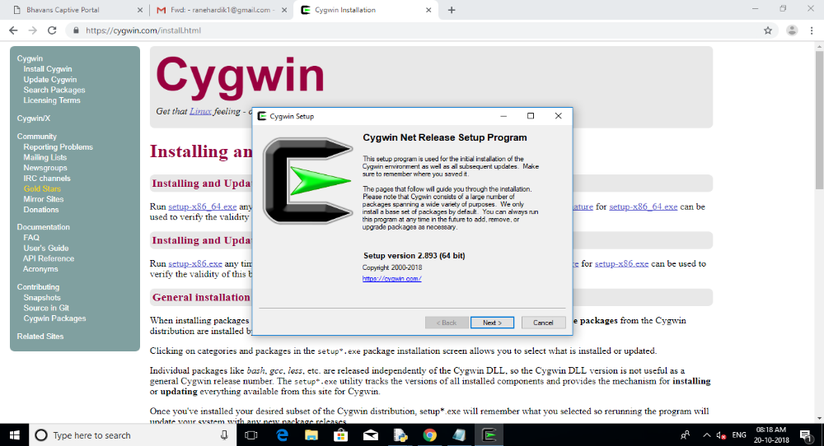

- Proceed further by clicking on next & then choose a download source i.e. install from internet (default) & click on next.
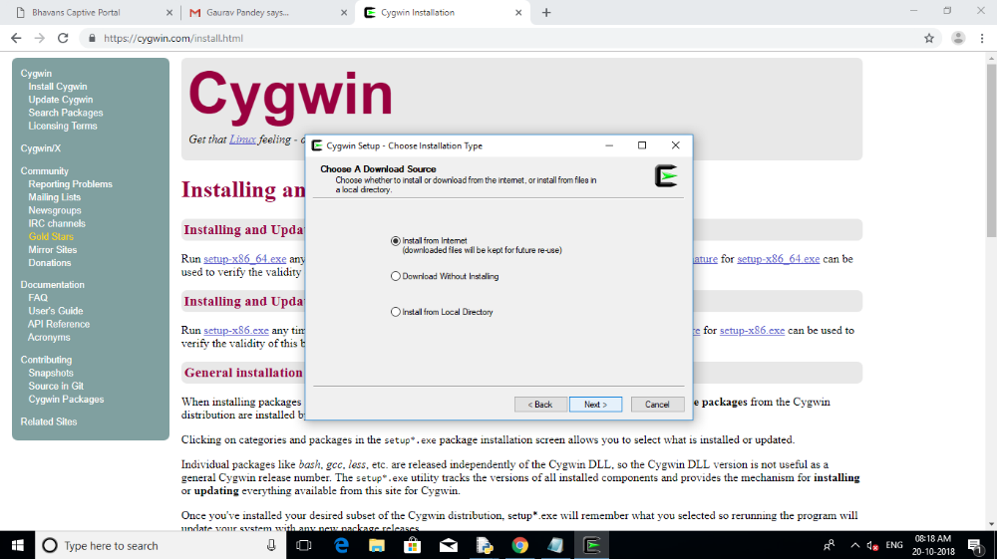
- Now select root installation directory where cygwin is to be installed & select some installation parameters i.e. install for all users of system or just me.
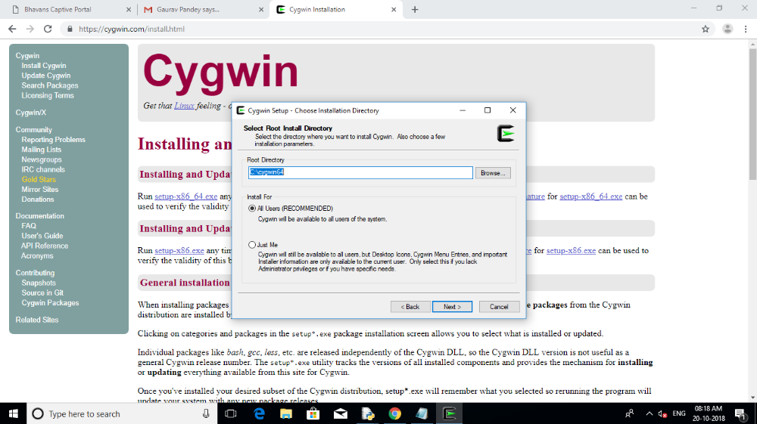

- Now select local package directory where you want the setup to store the installation files.
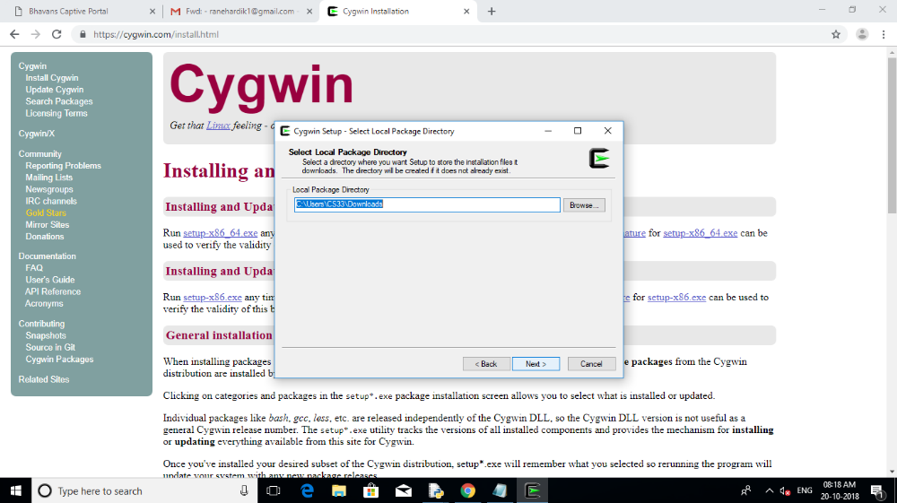

- Now select how you want the setup to be connected to an internet. Use default settings i.e. (system proxy setting).
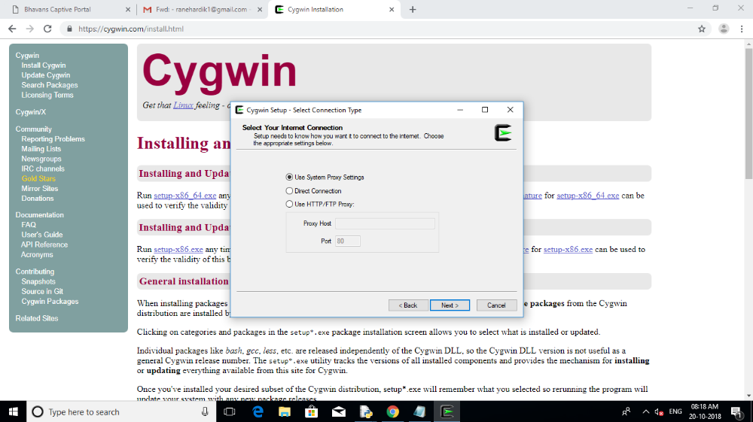

- Cygwin system setup download page appears. After finishing click on next. (displays progress of download or installation) .
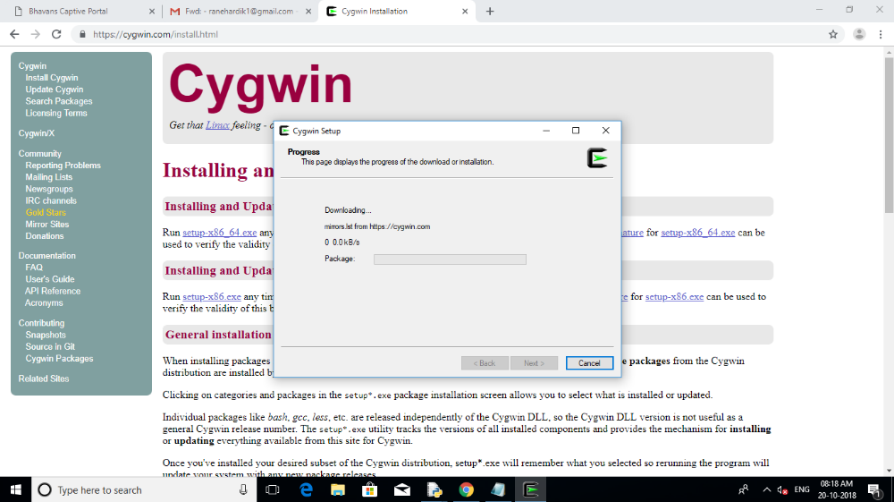

- Now choose the download sites from the given available sites or add your own site for downloading packages. (Select any 1 from the top 2 sites given in list).
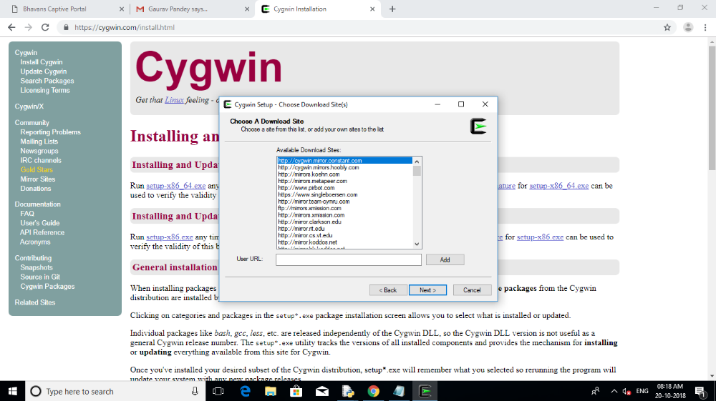

- Now cygwin packages are been downloaded. (progress window of the packages window).
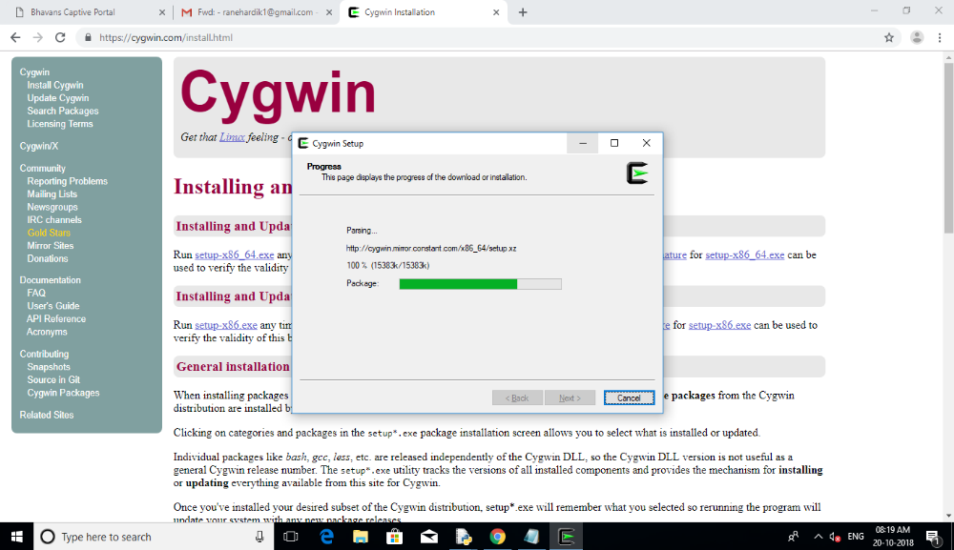
- Now select the packages for cygwin. Needs to install at least 3 packages for better binary cygwin environment. First search gcc-core& select the options as follows: gcc-core > devel > gcc-core: gnu compiler collection (c.openmp).
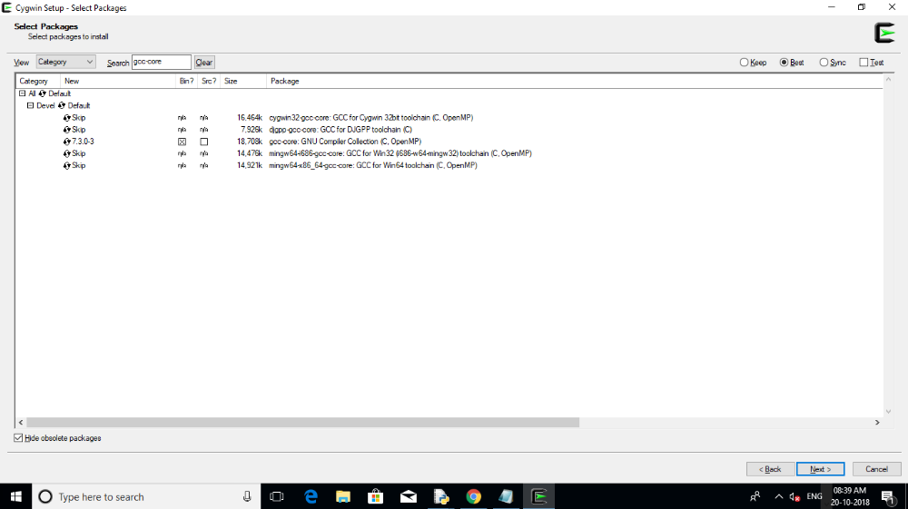

- Now select the next second package i.e. now search make& select the options as follows:- make > devel > make: the gnu version of 'make’ utility.
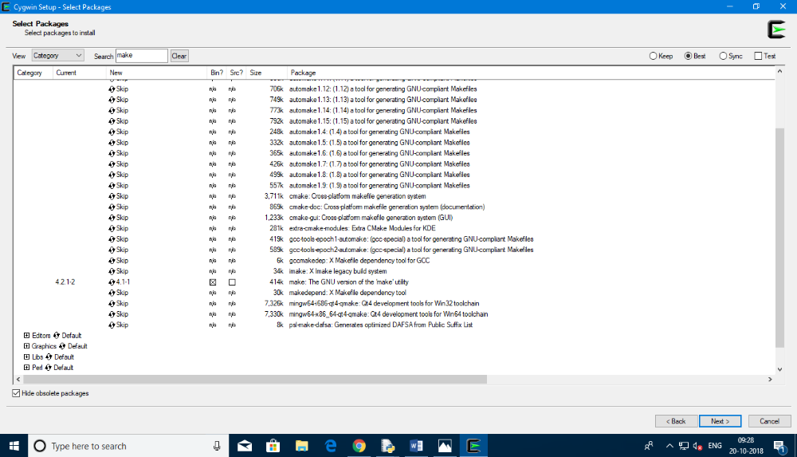
- Now select the next third package i.e. now search openssl& select the options as follows:- openssl > net > openssl: a general purpose cryptography toolkit with TLS implementation or select openssl-devel.
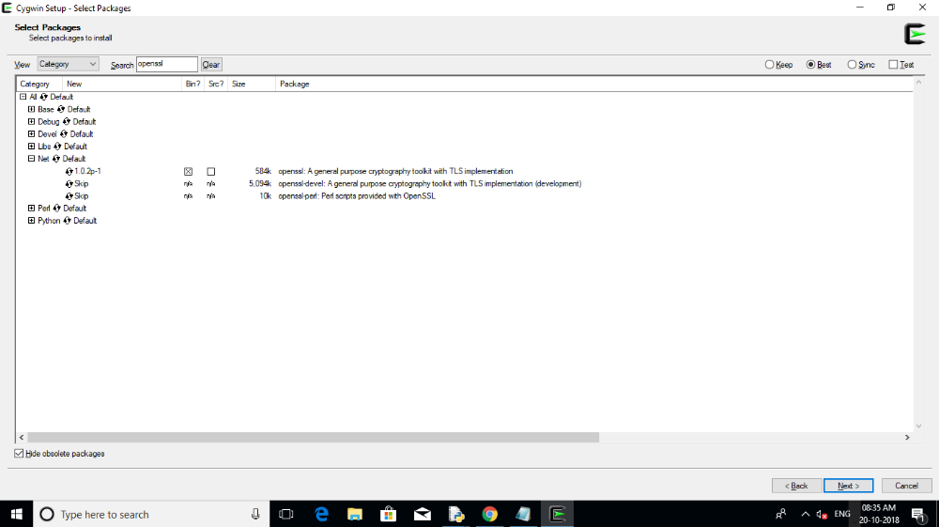

- Finally by selecting packages and clicking on next cygwin final setup starts to be installed. (Progress window of final installation).
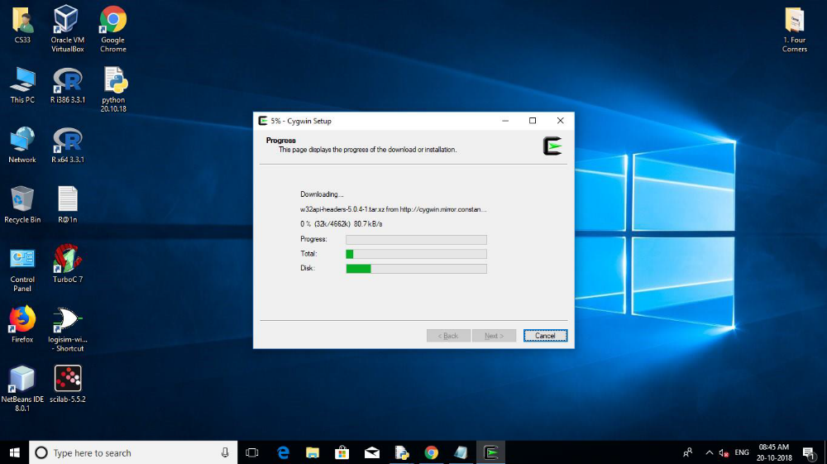
- The last step of the setup: The installation status & the create icon of cygwin to the desktop & in the start menu.
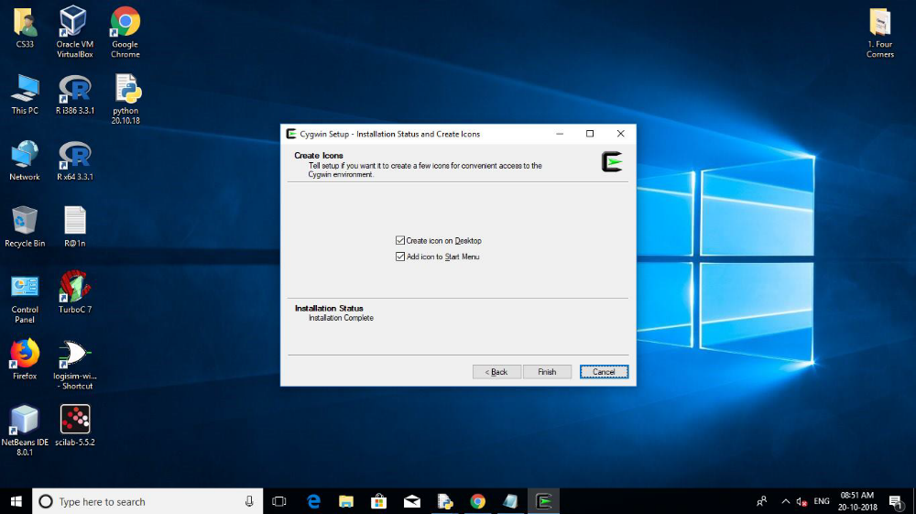

- Now open notepad & type a normal python program& save it in .py format.
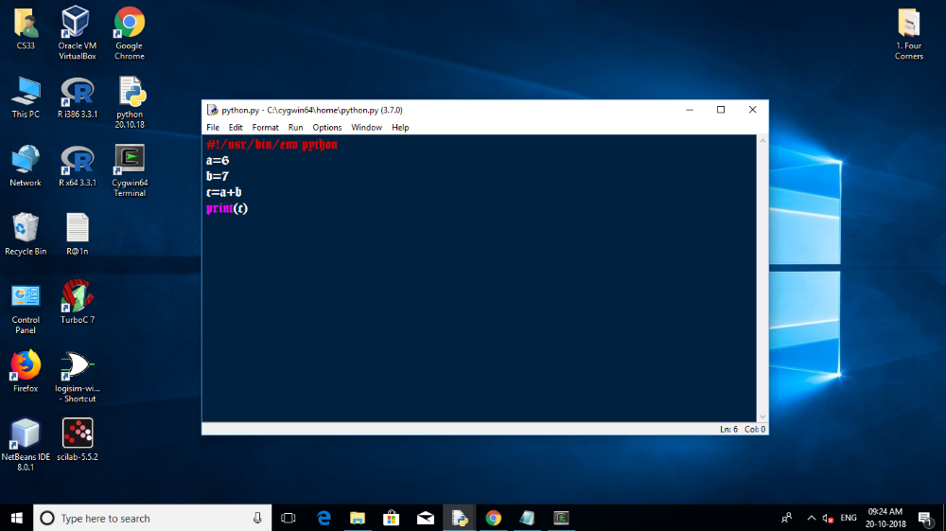

- Now save the file in the following order: cygwin64 > home > python.py (file name).
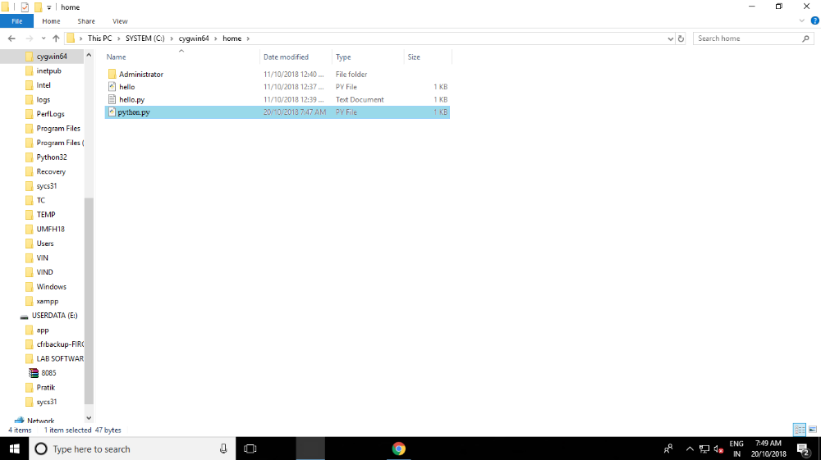

- Final execution in cygwin window.
